Template cholera case report form
Below is a template cholera surveillance case report form for use in collecting minimum standard case- based data on any patient meeting the applicable definition of a suspected cholera case (see definitions on page 5) presenting at any health facility.

All health facilities — public, private, faith-based, or non-governmental organizations (NGOs) with outpatient and/or inpatient facilities — are expected to report suspected cholera cases using this form. This includes health centres, hospitals, clinics, private practices, cholera treatment centres (CTCs), and cholera treatment units (CTUs). In addition, it is recommended that oral rehydration points (ORPs) also perform case-based reporting using this form. This template can be customised for use at ORPs (e.g., variables on cholera testing may not be applicable).
Guidance on how to report should be added to page 6 to describe local procedures for health-facility case-based surveillance.

Template cholera case report form

General information
Date of reporting by the health facility: [_Y_][_Y_][_Y_][_Y_] - [_M_][_M_] - [_D_][_D_]
Name of the reporting health facility:
1. Patient information
Unique patient identifier
First name(s) of the patient
Last name(s) of the patient
Age of the patient (in years)  [if the patient is under 1 year, record 0] |  |  | years
Patient’s sex at birth |  | - Female  - Male
Place of residence | Admin level 1  [e.g., region or province of  residence of the patient]
Place of residence | Admin level 2  [e.g., district of residence of the  patient]
Place of residence | Admin level 3  [e.g., health area or commune of  residence of the patient]
Place of residence | Admin level 4  [e.g., ward, municipal sector  or village of residence of the case]
Place of residence | Address of residence  [neighbourhood, street, house]
2. Clinical information
Date of visit  [Date the patient was consulted or admitted] |  | [_Y_][_Y_][_Y_][_Y_] - [_M_][_M_] - [_D_][_D_]
Readmission  [within 5 days of discharge from any health facility where the patient was previously admitted for a clinical condition suggestive of cholera] |  | - Yes  - No  - Unknown
Referral from another health facility |  | - Yes  - No  - Unknown
If the patient was referred, name of referring health facility
Date the patient had the first symptoms of acute watery diarrhoea  [Acute: lasting less than seven days;  Watery: non-bloody liquid stools that may contain mucous;  Diarrhoea: three or more loose stools within a 24-hour  period] |  | [_Y_][_Y_][_Y_][_Y_] - [_M_][_M_] - [_D_][_D_]
How has the patient been admitted to the reporting health facility?  [Inpatient: Inpatient care requires a hospital stay;  Outpatient: Outpatient care, also called ambulatory or day |  | - Inpatient  - Outpatient  - Unknown

patient care, does not require hospitalisation]
What was the patient’s level of dehydration at admission?  [refer to dehydration level definitions at the bottom of the form] | - None  - Some dehydration  - Severe dehydration  - Unknown
What was the patient’s outcome?  [Institutional death: death of a suspected or confirmed cholera case, with no other known cause of death, that occurs after arriving at a health facility;  Community death: death of a suspected or confirmed cholera case, with no other known cause of death, that  occurs before reaching a health facility] | - Alive and discharged  - Alive and transferred  - Died at health facility (institutional death)  - Dead on arrival at a health facility (community death)
Date the case was discharged or transferred (if alive) or date of death (if died) | [_Y_][_Y_][_Y_][_Y_] - [_M_][_M_] - [_D_][_D_]
3. Cholera testing
Was a specimen collected for cholera testing? | - Yes  - No  - Unknow  n | If yes, date of specimen collection:  [_Y_][_Y_][_Y_][_Y_] - [_M_][_M_] - [_D_][_D_]
RDT result  [Inconclusive RDT result: neither positive nor negative (e.g., absence of control line, uncertain test line due to obscuring anomaly or poor background clearance of the test strip)] | - Positive O1  - Positive O139  - Positive O1 and O139  - Negative  - Inconclusive  - Not performed
Was a specimen sent to the laboratory for culture or PCR testing? | - Yes  - No  - Unknown
Date of specimen receipt at the laboratory | [_Y_][_Y_][_Y_][_Y_] - [_M_][_M_] - [_D_][_D_]
Date of laboratory result | [_Y_][_Y_][_Y_][_Y_] - [_M_][_M_] - [_D_][_D_]
Culture (including seroagglutination) result | - Positive O1  - Positive O139  - Negative  - Inconclusive  - Not performed  - Pending
PCR result – serogroup | - Positive O1  - Positive O139  - Negative  - Inconclusive  - Not performed  - Pending
PCR result – toxigenicity | - Toxigenic  - Non toxigenic  - Inconclusive  - Not performed  - Pending
Antimicrobial susceptibility testing (AST)  [Check all that apply] | - Susceptibility to Azithromycin (AZ)  - Susceptibility to Ciprofloxacin (CIP)  - Susceptibility to Pefloxacin (PEF)

Criteria for assessing level of dehydration at admission
- Susceptibility to Tetracycline (TE)
- Susceptibility to Doxycycline (DO)
- Susceptibility to Erythromycin (EM)
- Not performed
- Pending

None | Some | Severe
No clinical signs of dehydration:  - Awake and alert  - Normal pulse  - Normal thirst  - Eyes not sunken  - Skin pinch normal | No danger signs AND at least two of the following signs:  - Irritable or restless  - Sunken eyes  - Rapid pulse  - Thirsty (drinks eagerly)  - Skin pinch goes back slowly | One or more danger signs:  - Lethargic or unconscious  - Absent or weak pulse  - Respiratory distress  OR at least two of the following:  - Sunken eyes  - Not able to drink or drinks poorly  - Skin pinch goes back very slowly

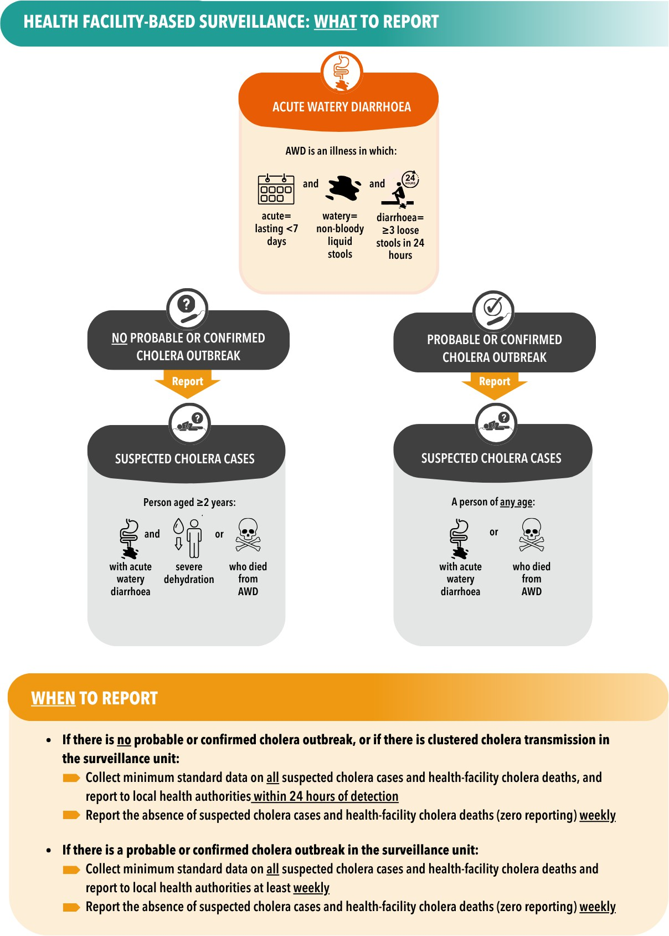

Section to be customised to describe local procedures for reporting health- facility case-based data. <<<CLICK HERE TO EDIT>>

